Name –Ayan Sadhukhan

Registration Number- 19BEC1448

*Question 1:* Write a program that reads n elements and finds the sum of product of consecutive numbers.

*Code:*

#include<stdio.h>

int main()

{

int x[20],n,sum=0;

printf("Enter the length of the array ");

scanf("%d",&n);

for(int i=0;i<n;i++)

{

printf("Enter the element ");

scanf("%d",&x[i]);

}

for (int i=0;i<n-1;i++)

{

sum=sum+x[i]\*x[i+1];

}

printf("The sum of the consecutive elements in the array is %d ",sum);

}

*Output:*

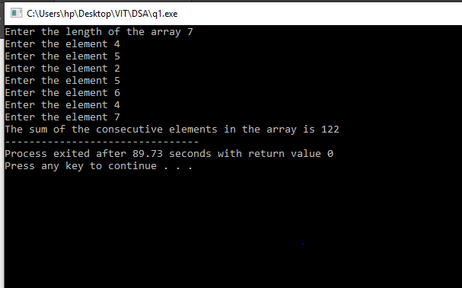

*Question 2:* Find the value of the following series:

(x1 + x2)\*x3 + (x2 + x3)\*x4 + (x3 + x4)\*x5 + …..

*Code:*

#include<stdio.h>

int main()

{

int x[20],n,sum=0;

printf("Enter the length of the array ");

scanf("%d",&n);

for(int i=0;i<n;i++)

{

printf("Enter the element ");

scanf("%d",&x[i]);

}

for (int i=0;i<n-2;i++)

{

sum=sum+(x[i]+x[i+1])\*x[i+2];

}

printf("The sum of the consecutive elements in the array is %d ",sum);

}

*Output:*

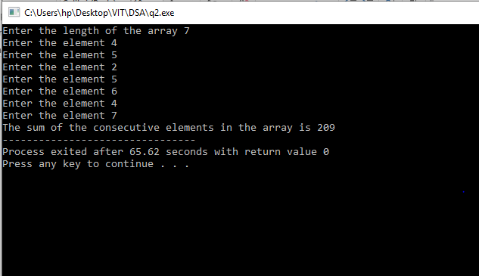

*Question 3:* Find the value of the following series:

(x1 + x2)\*x3 + (x2 + x3)\*x4 + (x3 + x4)\*x5 + …..

*Code:*

#include<stdio.h>

int main()

{

int x[20],n,sum=1;

printf("Enter the length of the array ");

scanf("%d",&n);

for(int i=0;i<n;i++)

{

printf("Enter the element ");

scanf("%d",&x[i]);

}

for (int i=0;i<n-2;i++)

{

sum=sum\*(x[i]+x[i+2]);

}

printf("The sum of the consecutive elements in the array is %d ",sum);

}

*Output:*

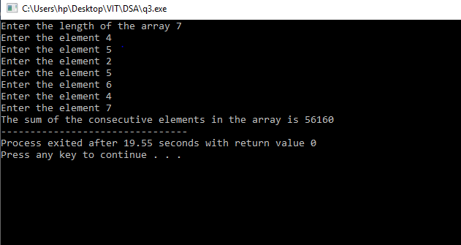

*Question 4:* Find the value of the following series:

(x1 - x2)\*(x2 + x3) + (x2 - x3)\*(x3 + x4) + ….. + (xnn2 - xn1) \*( xn1 + xn)

*Code:*

#include<stdio.h>

int main()

{

int x[20],n,sum=0;

printf("Enter the length of the array ");

scanf("%d",&n);

for(int i=0;i<n;i++)

{

printf("Enter the element ");

scanf("%d",&x[i]);

}

for (int i=0;i<n-2;i++)

{

sum=sum+(x[i]-x[i+1])\*(x[i+1]+x[i+2]);

}

printf("The sum of the consecutive elements in the array is %d ",sum);

}

*Output:*

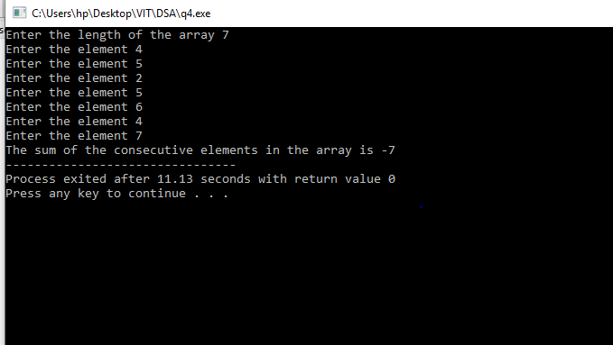

*Question 5:* Find the value of the following series:

(x1 \* xn) + (x2 \* xn1) +(x3 \* xn2) + …..+(xn \* x1)

*Code:*

#include<stdio.h>

int main()

{

int x[20],n,sum=0;

printf("Enter the length of the array ");

scanf("%d",&n);

for(int i=0;i<n;i++)

{

printf("Enter the element ");

scanf("%d",&x[i]);

}

int f=n-1;

for (int i=0;i<n;i++)

{

sum=sum+(x[i]\*x[f]);

f=f-1;

}

printf("The sum of the consecutive elements in the array is %d ",sum);

}

*Output:*

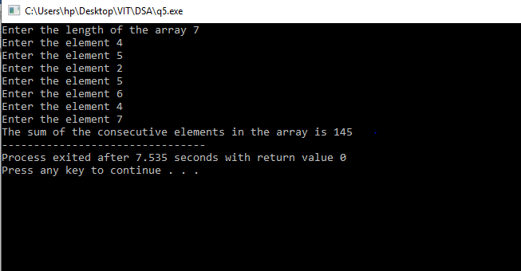

*Question 6:*

Write a program, which outputs local maxims. A number xi is local maximum if it is more than both xi1 and xi+1. If array elements are 25, 19, 22, 23, 21, 12, 10, 17, 11, 13, 10 then 23, 17 and 13 are local maxims.

*Code:*

#include<stdio.h>

int main()

{

int n=0,a[20];

printf("Enter the length of the array \n");

scanf("%d",&n);

for(int i=0;i<n;i++)

{

printf("Enter the element ");

scanf("%d",&a[i]);

}

int b[20];

int f=0;

for (int i=1;i<n;i++)

{

if (a[i]>a[i-1] && a[i]>a[i+1])

{

b[f]=a[i];

f=f+1;

}

}

for(int i=0;i<f;i++)

{

printf("%d ",b[i]);

}

}

*Output:*

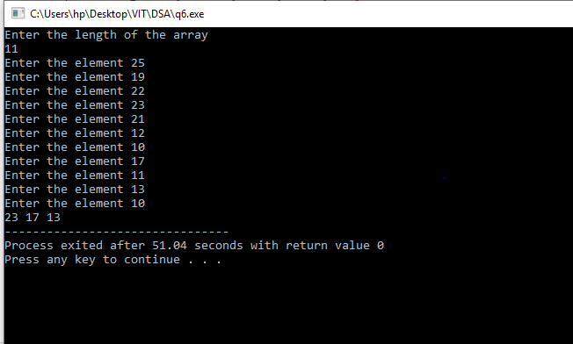

*Question 7:*

Write a program that outputs smallest ‘i’ such that xi is even. In above case 3. (Because first even number is 22).

*Code:*

#include<stdio.h>

int main()

{

int n,a[20];

printf("Enter the length of the array ");

scanf("%d",&n);

for (int i=0;i<n;i++)

{

printf("Enter the element ");

scanf("%d",&a[i]);

}

for(int i=0;i<n;i++)

{

if (a[i]%2==0)

{

printf("%d",(i+1));

break;

}

}

}

*Output:*

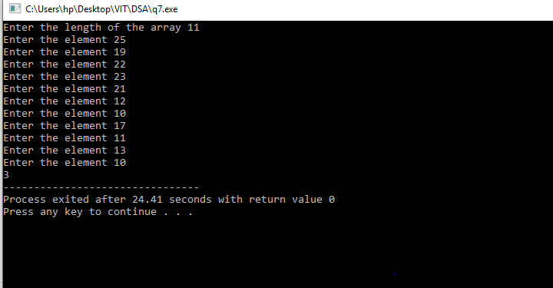

*Question 8:*

Write a program that outputs smallest ‘i’ such that xi and xi+1 are both even. In above case 6. (Because 12 and 10 are even).

*Code:*

#include<stdio.h>

int main()

{

int n,a[20];

printf("Enter the number of elements in array ");

scanf("%d",&n);

for(int i=0;i<n;i++)

{

printf("Enter the elements ");

scanf("%d",&a[i]);

}

for (int i=0;i<n-1;i++)

{

if(a[i]%2==0 && a[i+1]%2==0)

{

printf("%d",(i+1));

break;

}

}

}

*Output:*

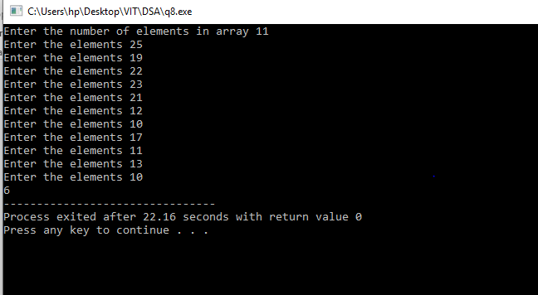

*Question 9:*

Write a program to find weighted sum. The weight of an element is w, if it is more than w elements after it. 25.10+19.6+22.7+23.7+21.6+12.3+10.0+17.3+11.1+13.1+10.0=916.

*Code:*

#include<stdio.h>

int main()

{

int n,a[20];

printf("Enter the length of the array ");

scanf("%d",&n);

for(int i=0;i<n;i++)

{

printf("Enter the element ");

scanf("%d",&a[i]);

}

int sum=0;

for(int i=0;i<n;i++)

{ int f=0;

for(int j=i+1;j<n;j++)

{

if (a[i]>a[j])

{

f=f+1;

}

}

sum=sum+a[i]\*f;

}

printf("The weighted sum is %d ",sum);

return 0;

}

*Output:*

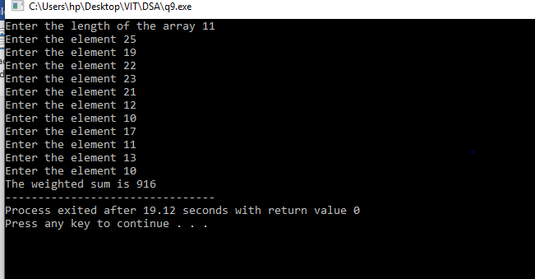

*Question 10:*

Do above problem when weight of an element is w, if it is more than w elements immediately after it. In above case 25.10+19.0+22.0+23.7+21.6+12.1+10.0+17.3+11.0+13.1+10.0=613.

*Code:*

#include<stdio.h>

int main()

{

int n,a[20];

printf("Enter the length of the array ");

scanf("%d",&n);

for(int i=0;i<n;i++)

{

printf("Enter the element ");

scanf("%d",&a[i]);

}

int sum=0;

for(int i=0;i<n;i++)

{ int f=0;

for(int j=i+1;j<n;j++)

{

if (a[i]>a[j])

{

f=f+1;

}

else{

break;

}

}

sum=sum+a[i]\*f;

}

printf("The weighted sum is %d ",sum);

return 0;

}

*Output:*

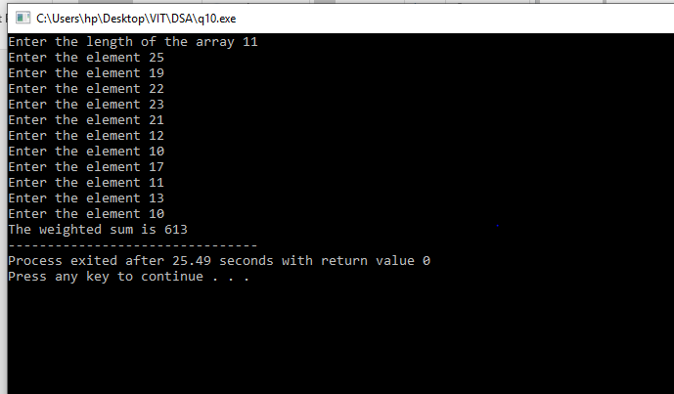

*Question 11:*

Write a program, which reads ‘k’ also. The program outputs a xi’s if it is more than next k numbers (i.e. xi+1, xi+2, …. , xi+k). If k=3 then for above input the output is 25, 23, 21, 17.

*Code:*

#include<stdio.h>

int main()

{

int n,a[20],k=0;

printf("Enter the length of the array ");

scanf("%d",&n);

printf("Enter the value of k: ");

scanf("%d",&k);

for(int i=0;i<n;i++)

{

printf("Enter the element ");

scanf("%d",&a[i]);

}

int sum=0;

for(int i=0;i<n;i++)

{ int f=0;

for(int j=i+1;j<n;j++)

{

if (a[i]>a[j])

{

f=f+1;

}

else{

break;

}

}

if (f>=k)

{

printf("%d ",a[i]);

}

}

return 0;

}

*Output:*

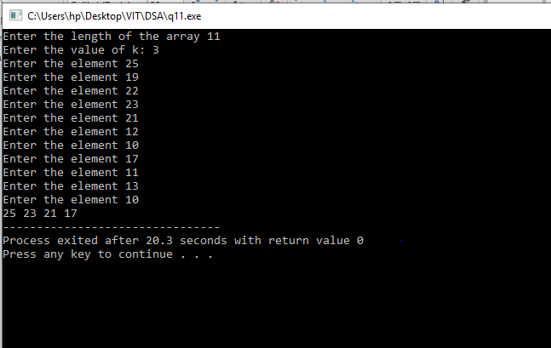

*Question 12:*

Write a program, which reads two arrays x1 … xn and y1 … yn. The program outputs the value of (x1 \* yn) + (x2 \* yn1) + (x3 \* yn2) + … + (xn \* y1)

*Code:*

#include<stdio.h>

int main()

{

int n,m,a[20],b[20];

printf("Enter the length of the first array ");

scanf("%d",&n);

printf("Enter the length of the second array ");

scanf("%d",&m);

for(int i=0;i<n;i++)

{

printf("Enter the elements ");

scanf("%d",&a[i]);

}

for(int i=0;i<m;i++)

{

printf("Enter the elements ");

scanf("%d",&b[i]);

}

int f=m-1;

int sum=0;

for(int i=0;i<n;i++)

{

sum=sum+(a[i]\*b[f]);

f=f-1;

}

printf("The sum is %d",sum);

}

*Output:*

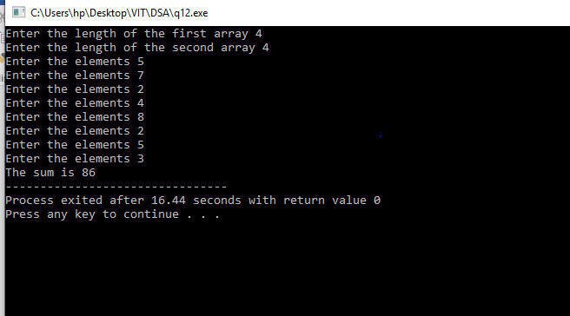

*Question 13:*

Write a program, which reads two arrays x1 … xn and y1 …yn. The program outputs the value of

x1\*(y1+y2+y3+ …+yn) + x2\*(y2+y3+y4+ …+yn) + x3\*(y3+y4+…+yn) +….+ xn1\*(yn1+yn) + xn\*yn

*Code:*

#include<stdio.h>

int main()

{

int n,m,a[20],b[20];

printf("Enter the length of the first array ");

scanf("%d",&n);

printf("Enter the length of the second array ");

scanf("%d",&m);

for(int i=0;i<n;i++)

{

printf("Enter the elements ");

scanf("%d",&a[i]);

}

for(int i=0;i<m;i++)

{

printf("Enter the elements ");

scanf("%d",&b[i]);

}

int f=m-1;

int sum=0;

int pro=0;

for(int i=0;i<n;i++)

{ pro=0;

for(int j=i;j<m;j++)

{

pro=pro+b[j];

}

sum=sum+(a[i]\*pro);

}

printf("The sum is %d",sum);

}

*Output:*

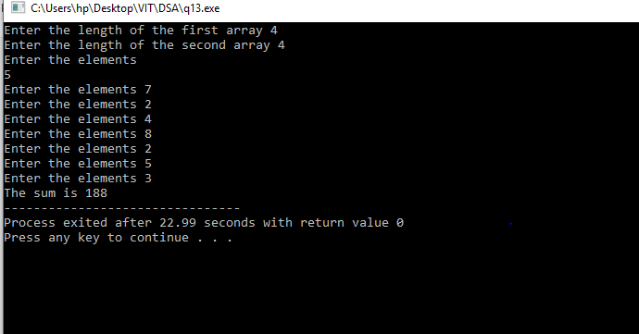

*Question 14:*

Write a program, which reads two arrays x1 … xn and y1 …yn. The program outputs the value of

x1\*y1+y2+…+yn) + (x1+x2)\*y2+y3+…+yn) + (x1+x2+x3)\*y3+y4+…+yn) +...+ x1+x2+…+xn)\*yn

*Code:*

#include<stdio.h>

int main()

{

int n,m,a[20],b[20];

printf("Enter the length of the first array ");

scanf("%d",&n);

printf("Enter the length of the second array ");

scanf("%d",&m);

for(int i=0;i<n;i++)

{

printf("Enter the elements ");

scanf("%d",&a[i]);

}

for(int i=0;i<m;i++)

{

printf("Enter the elements ");

scanf("%d",&b[i]);

}

int f=m-1;

int sum=0;

int pro=0;

int p=0;

for(int i=0;i<n;i++)

{ pro=0;

for(int j=i;j<m;j++)

{

pro=pro+b[j];

}

p=p+a[i];

sum=sum+(p\*pro);

}

printf("The sum is %d",sum);

}

*Output:*

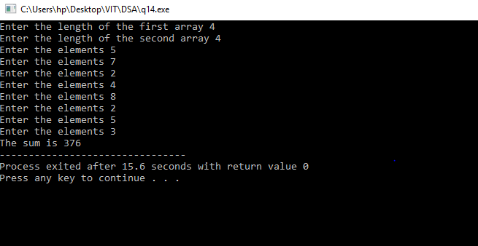

*Double Dimensional Array*

*Question 1:*

Write a program, which prints the diagonal elements of the matrix.

*Code:*

#include<stdio.h>

int main()

{

int n,m,a[10][10];

printf("Enter the row length of the matrix ");

scanf("%d",&n);

printf("Enter the column length of the matrix ");

scanf("%d",&m);

for(int i=0;i<n;i++)

{

for(int j=0;j<m;j++)

{

printf("Enter the element ");

scanf("%d",&a[i][j]);

}

}

printf("The array is \n");

for(int i=0;i<n;i++)

{

for(int j=0;j<m;j++)

{

printf("%d ",a[i][j]);

}

printf("\n");

}

printf("The diagonal elements of the array are ");

for(int i=0;i<n;i++)

{

for(int j=0;j<m;j++)

{

if (i==j ||(i+j)==n-1)

{

printf("%d ",a[i][j]);

}

}

}

}

*Output:*

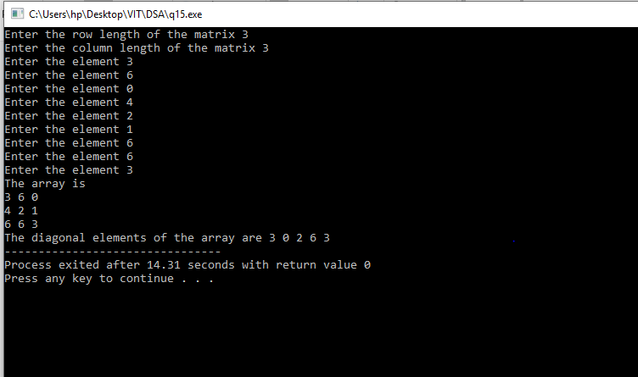

*Question 2:*

Write a program, which reads two matrixes and finds their sum.

*Code:*

#include<stdio.h>

int main()

{

int n,m,a[10][10],b[10][10],c[10][10];

printf("Enter the row length of the two matrix ");

scanf("%d",&n);

printf("Enter the column length of the two matrix ");

scanf("%d",&m);

printf("Enter the elements of the first matrix \n");

for(int i=0;i<n;i++)

{

for(int j=0;j<m;j++)

{

printf("Enter the element ");

scanf("%d",&a[i][j]);

}

}

printf("Enter the elements of the second matrix \n");

for(int i=0;i<n;i++)

{

for(int j=0;j<m;j++)

{

printf("Enter the element ");

scanf("%d",&b[i][j]);

}

}

printf("The first array is \n");

for(int i=0;i<n;i++)

{

for(int j=0;j<m;j++)

{

printf("%d ",a[i][j]);

}

printf("\n");

}

printf("The second array is \n");

for(int i=0;i<n;i++)

{

for(int j=0;j<m;j++)

{

printf("%d ",b[i][j]);

}

printf("\n");

}

printf("The sum of the two arrays is \n ");

for(int i=0;i<n;i++)

{

for(int j=0;j<m;j++)

{

c[i][j]=a[i][j]+b[i][j];

}

}

for(int i=0;i<n;i++)

{

for(int j=0;j<m;j++)

{

printf("%d ",c[i][j]);

}

printf("\n");

}

}

*Output:*

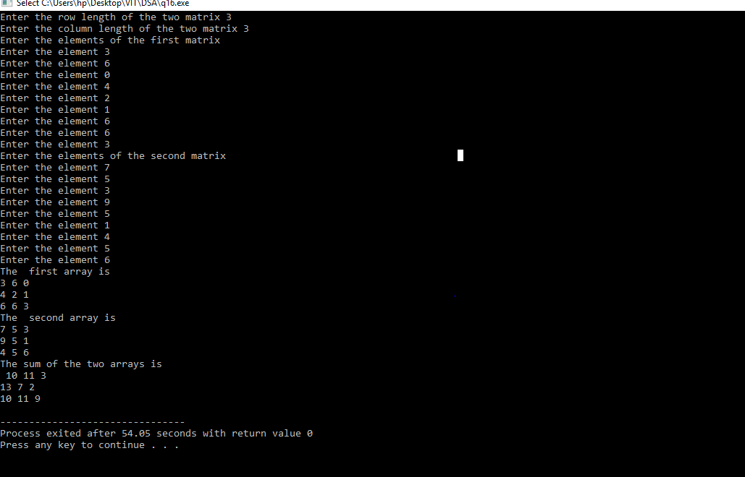

*Question 3:*

Write a program, which reads two matrixes and finds their product.

*Code:*

#include<stdio.h>

int main()

{

int n,m,a[10][10],b[10][10],c[10][10],n1,m1;

printf("Enter the row length of the first matrix ");

scanf("%d",&n);

printf("Enter the column length of the first matrix ");

scanf("%d",&m);

printf("Enter the row length of the first matrix ");

scanf("%d",&n1);

printf("Enter the column length of the first matrix ");

scanf("%d",&m1);

printf("Enter the elements of the first matrix \n");

for(int i=0;i<n;i++)

{

for(int j=0;j<m;j++)

{

printf("Enter the element ");

scanf("%d",&a[i][j]);

}

}

printf("Enter the elements of the second matrix \n");

for(int i=0;i<n1;i++)

{

for(int j=0;j<m1;j++)

{

printf("Enter the element ");

scanf("%d",&b[i][j]);

}

}

printf("The first array is \n");

for(int i=0;i<n;i++)

{

for(int j=0;j<m;j++)

{

printf("%d ",a[i][j]);

}

printf("\n");

}

printf("The second array is \n");

for(int i=0;i<n1;i++)

{

for(int j=0;j<m1;j++)

{

printf("%d ",b[i][j]);

}

printf("\n");

}

int sum=0;

if (m!=n1)

{

printf("The array cannot be multiplied \n");

}

else

{

printf("The product of the two arrays is \n ");

for ( int i = 0 ; i < n ; i++ )

{

for ( int j = 0 ; j < m ; j++ )

{

for ( int k = 0 ; k < n1 ; k++ )

{

sum = sum + a[i][k]\*b[k][j];

}

c[i][j] = sum;

sum = 0;

}

}

for(int i=0;i<n;i++)

{

for(int j=0;j<m;j++)

{

printf("%d ",c[i][j]);

}

printf("\n");

}

}

}

*Output:*

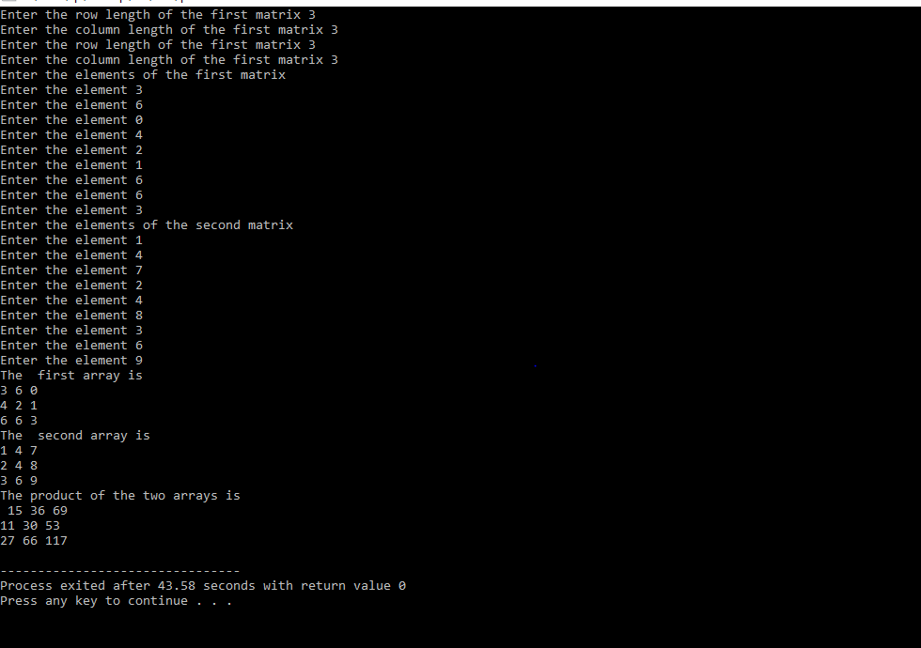

*Question 4:*

Write program, which finds the minimum element of every row.

*Code:*

#include<stdio.h>

int main()

{

int n,m,a[10][10],b[10][10],c[10][10];

printf("Enter the row length of the two matrix ");

scanf("%d",&n);

printf("Enter the column length of the two matrix ");

scanf("%d",&m);

printf("Enter the elements of the first matrix \n");

for(int i=0;i<n;i++)

{

for(int j=0;j<m;j++)

{

printf("Enter the element ");

scanf("%d",&a[i][j]);

}

}

printf("The array is \n");

for(int i=0;i<n;i++)

{

for(int j=0;j<m;j++)

{

printf("%d ",a[i][j]);

}

printf("\n");

}

printf("The elements are ");

for(int i=0;i<n;i++)

{ int min=a[i][0];

for(int j=0;j<m;j++)

{

if (a[i][j]<min)

{

min=a[i][j];

}

}

printf("%d ",min);

}

}

*Output:*

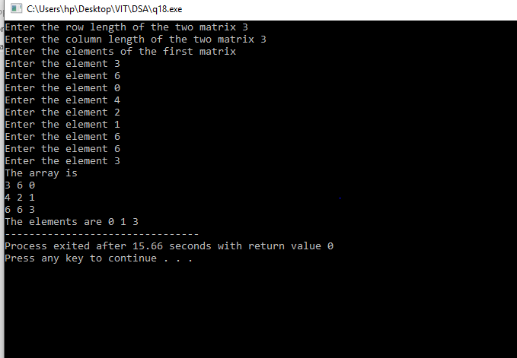

*Question 5:*

Write program, which finds the maximum of all elements computed in above question.

*Code:*

#include<stdio.h>

int main()

{

int n,m,a[10][10],b[10][10],c[10][10];

printf("Enter the row length of the two matrix ");

scanf("%d",&n);

printf("Enter the column length of the two matrix ");

scanf("%d",&m);

printf("Enter the elements of the first matrix \n");

for(int i=0;i<n;i++)

{

for(int j=0;j<m;j++)

{

printf("Enter the element ");

scanf("%d",&a[i][j]);

}

}

printf("The array is \n");

for(int i=0;i<n;i++)

{

for(int j=0;j<m;j++)

{

printf("%d ",a[i][j]);

}

printf("\n");

}

printf("The Minimum element is ");

int min=a[0][0];

for(int i=0;i<n;i++)

{

for(int j=0;j<m;j++)

{

if (a[i][j]<min)

{

min=a[i][j];

}

}}

printf("%d ",min);

}

*Output:*

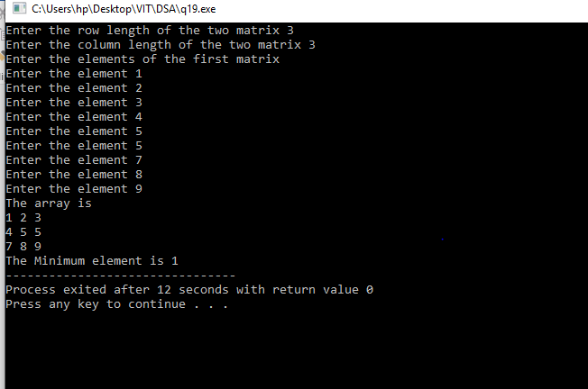

*Question 20:*

Write a program, which divides every row by corresponding diagonal element.

Input Output

3 6 0 9 1 2 0 3

4 2 1 6 2 1 0.5 3

6 6 3 12 2 2 1 4

*Code:*

#include<stdio.h>

int main()

{

int n,m,a[10][10];

int b[10][10];

printf("Enter the row length of the two matrix ");

scanf("%d",&n);

printf("Enter the column length of the two matrix ");

scanf("%d",&m);

printf("Enter the elements of the first matrix \n");

for(int i=0;i<n;i++)

{

for(int j=0;j<m;j++)

{

printf("Enter the element ");

scanf("%d",&a[i][j]);

}

}

int k[10],c=0;

printf("The array is \n");

for(int i=0;i<n;i++)

{

for(int j=0;j<m;j++)

{

printf("%d ",a[i][j]);

if(i==j)

{

k[c]=a[i][j];

c=c+1;

}

}

printf("\n");

}

printf("The resultant array is \n");

int min=a[0][0],f=0;

for(int i=0;i<n;i++)

{

for(int j=0;j<m;j++)

{

b[i][j]=float(a[i][j]/k[f]);

}

f=f+1;

}

for(int i=0;i<n;i++)

{

for(int j=0;j<m;j++)

{

printf("%d ",b[i][j]);

}

printf("\n");

}

}

*Output:*

